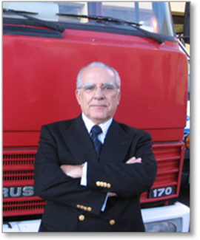
VASCO V. GARCIA
A qualified academic, research biologist and ecologist, Vasco Garcia was one of the Founders of the University of the Azores (1976). During his 40-year long career, starting at the Scientific Research Institute of Angola in 1966, followed for some years in France at the Institute National de Recherches Agronomiques and the CNRS-National Scientific Research Center. He founded the Applied Ecology Laboratory, the first research and teaching facility of this kind in the Azores. He lectured biology and environmental sciences for more than 30 years, both at undergraduate and post-graduate levels, in Portugal and abroad.
Prof. Vasco Garcia was a Member of the Azores Parliament (1980-84), of the Portuguese Parliament (1980) and the European Parliament (1986-94).
He is the author of numerous science papers and reports, and has published hundreds of specialized technical articles and views on science journals and newspapers alike. He is the author of “The Azores and future Europe”, published in 2000
As a member of the US Congress/European Parliament Delegation and of the US/Portugal Bilateral Commission for several years, as well as President of the University of the Azores (1995-2003), Vasco Garcia has paid particular attention to Transatlantic Relations involving the Azores, the US and Canada.
He retired in 2003 as President Emeritus of the University of the Azores.
From 2004 to 2007, he chaired the National Council for Social Affairs in Higher Education and is an Honorary Member of the European Parliament. Since January 2007, Prof. Garcia took office as President of the Humanitarian Association of Volunteer Firefighters of Ponta Delgada (AHBVPD).
In February 2009, he was elected President of the Azores Firefighters’ Federation/Eastern Group and as such, he has vouch to expand the relationship of both firefighters’ organizations with North America.
Holding a Ph.D. degree from the University of Marseilles and another from the University of the Azores, he graduated in Biological Sciences from the University of Coimbra. Vasco Garcia received the Azores Insignia of Merit on June 1, 2009.



